DrawCut – Mimaki Plotter

There are several ways to connect to a Mimaki Plotter, depending on how hold it is.

Method 1:
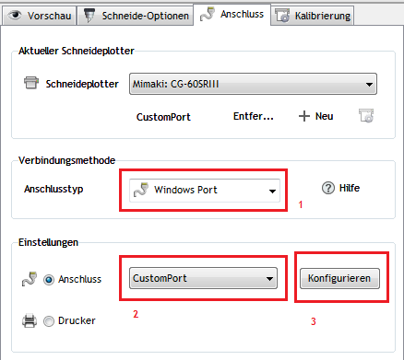
1. Select “Windows Port”
2. Choose “CustomPort”
3. Click “Configure”

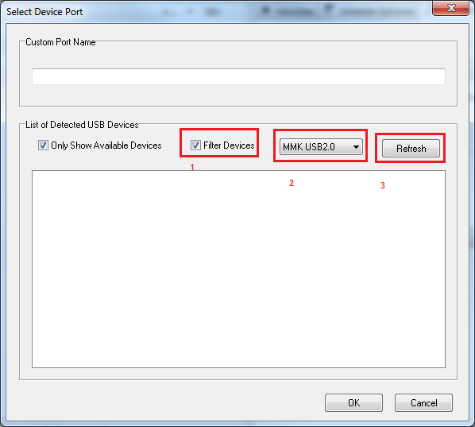
1. Select “Filter Devices”
2. Select the “MMK USB2.0” USB filter.
3. Click “Refresh” to display a list of matching port.

If you see anything available in the listbox underneath the “Refresh” button, click on it to select it, and click “OK”

Method 2:

If you have a CG SRIII, do the following:
Download and install this file:
https://mimaki.com/product/cutting/c-roll/cg-srIII-series/driver.html?driver=81057
Then download and install the CG-SRIII Printer Driver ver1.60
https://mimaki.com/product/cutting/c-roll/cg-srIII-series/driver.html?driver=81076

Or you can choose and download the files from the Mimaki web site, based on your model.

You can find the Mimaki USB Driver and Windows Printer drivers at:
https://mimaki.com/download/cutting.html
Select CG-FCXII or CG-SRIII

For CG-SRIII, you can directly go to:
https://mimaki.com/product/cutting/c-roll/cg-srIII-series/download.html

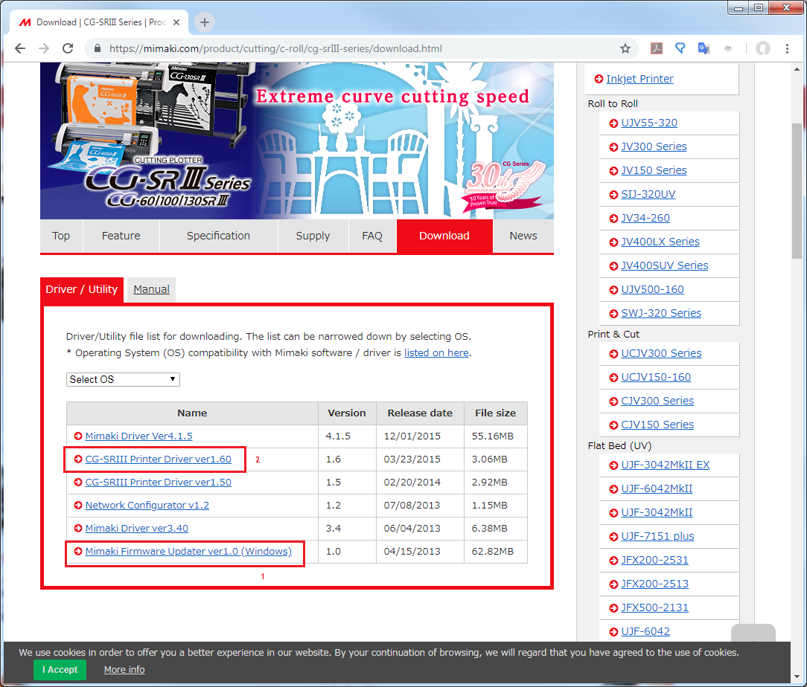

After installing the Mimaki Printer driver, make sure that it is set to the CG Port.

Select the Mimaki Printer driver in DrawCut by doing the following:
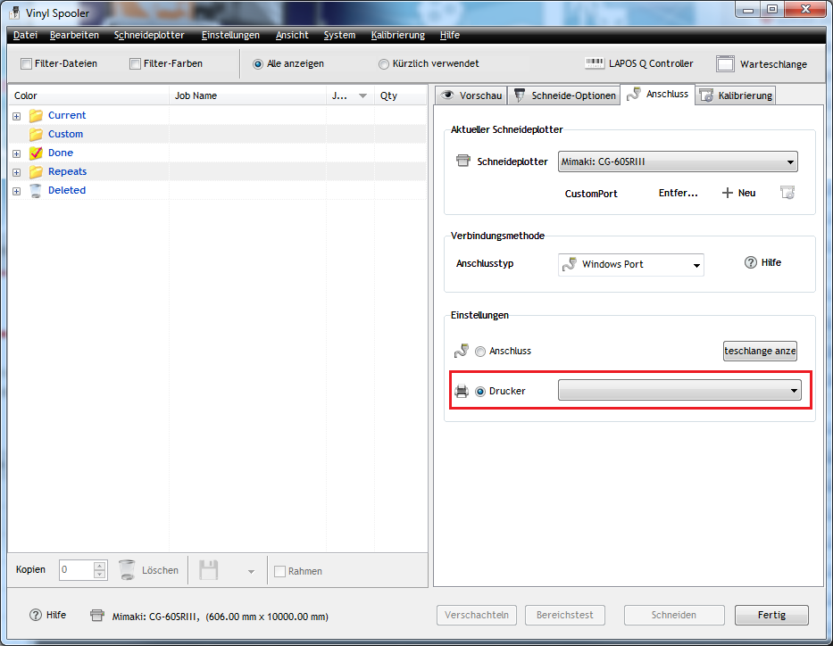
Select the mimaki printer in the printer lists.

